Evidence and Investigation Unit
Interactive Study Guide
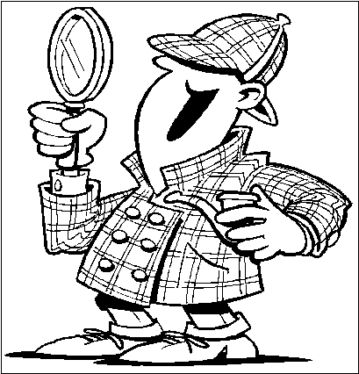

Words to know:
-Chromatography -Crime scene
-Classification -Suspects
-Evidence -Motive
-Forensics(http://investigation.discovery.com/forensics/videos/inside-the-csi-lab-science-for-the-courtroom.htm)
-Opportunity -Graphology
-Clues -Investigation
-Latent Fingerprint

When a crime has been committed the police are called to the crime scene to investigate. Evidence must be carefully collected and analyzed. To convict, the forensic evidence must prove the suspect guilty beyond a shadow of a doubt.

The processes of investigation and the gathering of evidence are the essences of scientific inquiry. Investigators must use their skills of questioning, predicting, observing, categorizing and inferring to solve a crime.

When a crime scene is investigated by police, all clues are examined. These clues might include tire prints, shoe prints, fingerprints, fibers, hair, written or print documents, and soil evidence.
***Be able to describe each of these main types of evidence (clues) that investigators use to solve crimes:

- Graphology & document analysis
- Footprint and fingerprint analysis
- Tire Prints
- Ink analysis and soil analysis
- Fabric forensics

Graphology and Document Analysis

- Graphology is the scientific study and analysis of handwriting, which depicts a person's personality. Examining handwriting is also a technique used in investigating a crime scene.

- Handwriting analysis is predicated on the fact that every person develops a unique form of handwriting

- Handwriting must be studied taking into consideration the size and slant of letters, word spacing, line spacing, the way zones are used, pressure and margins applied.
- Other factors such as signatures, connects and disconnects, and formation of individual letters may also be taken into consideration.

***Some indicators used in comparing handwriting samples are:
- spacing of letters/words
- slant of the letters
- pressure on the page
- formation of the loops in the letters
- dotting of the letters (I, j)
- crossing of the t
- how letters are joined
- a combination of printing/handwriting used
- size of words/letters
Two Games to try:

http://www.imcpl.org/kids/blog/?p=2639
What is a fingerprint?
http://ridgesandfurrows.homestead.com/fingerprint.html
http://sciencespot.net/Media/FrnsScience/fingerprintbasicscard.pdf
Fingerprints

- Fingerprints are the most reliable system of identification used today. Height, weight, hair colour, and appearance change over time. Fingerprints remain constant over a person’s lifetime.

- Although every person in the world has a unique set of fingerprints, all fingerprints can be classified as one of four basic patterns. The basic patterns are:
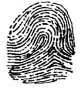
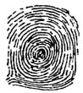

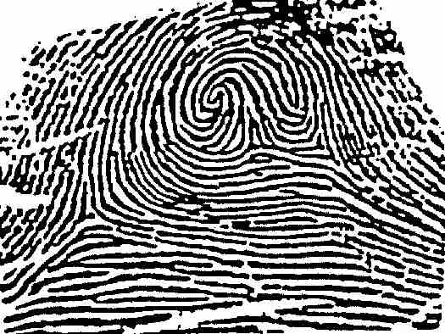

Arch Loop Whorl Composite

- There are variations on these patterns, such as a left loop, a right loop, a double loop, a mixed whorl and a tented arch.

- Every finger has a different print, and usually even a different pattern of print. The more prints that can be obtained, the more conclusive the identification can be.

- Latent Fingerprints are concealed; not developed, not clearly visible

Videos: http://investigation.discovery.com/forensics/videos/inside-the-csi-lab-science-for-the-courtroom.htm

http://science.howstuffworks.com/34406-solved-fingerprint-analysis-video.htm

Fingerprint Activities:
http://tip.duke.edu/independent_learning/cdrom_courses/clues_interactive.swf

http://www.trutv.com/shows/forensic_files/games/fingerprint/index.html

http://www.wonderville.ca/asset/fingerprint-activity

Pencil Print Activity
  - Rub a pencil lead (graphite) on a sheet of paper.
  - Rub your finger tip on the paper.
  - Put clear tape over your finger. The tape should be placed over the pad of the finger, not the tip.
  - Carefully pull off the tape and stick it on the paper.

What can we tell from FOOTPRINTS?
Foot Prints

- A footprint can tell us more than the type of shoe a person was wearing at the time the footprint was made.

- The size of the print allows investigators to estimate the height and gender of the person. The depth of the print gives information about the person’s weight.

- The distance between prints gives information about how fast the person was walking or running.

- Animals leave behind their own unique footprint, you often see it in movies or cartoons where an animal is ‘followed' based on their tracks.

- The amount of erosion of the print can give us information about when it was made.
Cars leave “footprints” too!
Tire prints can give us as much information about a car as footprints give us about people. Each tire has a different tread , and different cars have different types of tires. The type, weight, speed, age, and direction of a car can often be determined from a tire print.

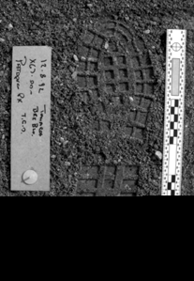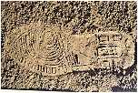

Tire Prints

- Tire prints can give us as much information about a car as footprints give us about a person. Each tire has a different tread, and different cars have different types of tires. The type, weight, speed, age and direction of a car can often be determined from a tire print.
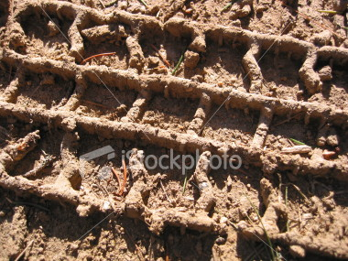



Ink Analysis

- Inks are made of different combinations of chemicals and dyes. Each of these chemicals has its own molecular weight.

- In paper chromatography, the molecules that make up inks are dissolved in a suitable solvent. They are then drawn up through absorbent paper. The lighter the weight of the molecules, the farther they will travel through the paper. The result will be a pattern on the paper that is unique to that particular ink.


Fabric Forensics

- Fabrics are made of woven fibers. We can compare fabrics by studying the size of the fibers and the type of weave. Fabrics can also be identified this way.

- The woven fibers of fabrics tend to trap particles within them. Hair, dirt, and blood trapped within the fibers can be seen clearly with a microscope. Clues found in fabrics are invaluable to criminologists.

- Police may find hair or fibers at the scene of a crime or on a suspect’s clothing. They examine the fibers in the lab to determine whether there is a match.

- Other possible tests for fabrics are: stretch, colourfastness, absorbency, wrinkling, thread test, flammability. Man-made fibers are more likely to melt and give off noxious fumes than natural fibers. Natural fibers are more likely to scorch and burn. Wool will smell of burnt proteins (hair).

Soil Analysis

- The colour of soil indicates the material that the soil is made up of. Soil rich in humus will be very dark in colour. Soil from an unpaved parking lot may contain very little humus and a lot of sand and pebbles to keep the water from collecting there. Police compare soil samples found at the scene of the crime with those found on a suspects clothing, shoes or in their car.

- The grittiness of soil can be tested by wetting a small amount of the soil and rubbing it between your thumb and two fingers. Soil made up of very small particles will feel smooth. Soil containing sand or larger, coarser particles will feel rougher and gritty.

- Other material found in the soil may include insect parts, fur, hair, bones, branches, etc.

Focus Questions

1. | What is a footprint? What characteristics make footprints unique from one another?
2. | What type of physical evidence can animals and humans leave?
3. | What information can you obtain about a person from a footprint?
4. | Where can footprints be obtained from?
5. | What is a fingerprint? How can you distinguish between fingerprints?
6. | Where can fingerprints be obtained from?
7. | What is an investigation? What is evidence?
8. | What are some observational skills?
9. | How does one interpret evidence?
10. | What physical evidence can be left behind at the crime scene?
11. | What can be interpreted from evidence left behind at the scene of the crime?
12. | How does one proceed to determine what happened at a crime scene?
13. | What questions can students ask, based on the evidence?
14. | What is the difference between an observation and an inference?
15. | How do you protect any evidence at the scene of a crime, and how can it be contaminated?
- List three ways investigators use evidence collected at a crime scene.

Video “Birthday Party Crime Scene”
 | http://www.youtube.com/watch?v=0FS_eT5PR1Q

